Your Safeguarding Policy



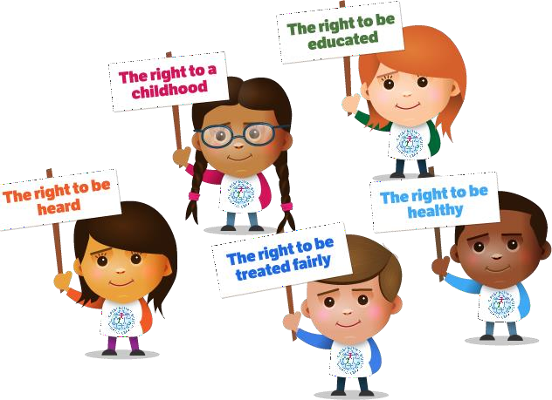

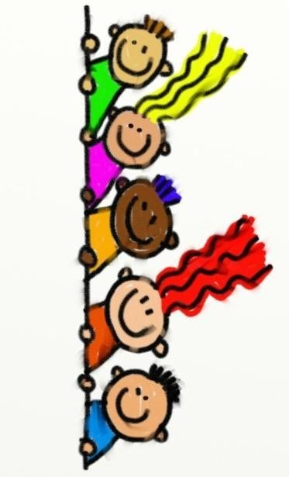

### What is this?

Your school has a Safeguarding Policy for staff, families and governors.

This ‘child friendly’ policy is designed for young people and this should be read as a guide to the main policy. We have written it so it easier to understand and not as long as the main policy.

### What is it for?

To help you decide what could be a ‘problem’ and where to get help and support.

# Is someone bullying you?

You must tell someone at school so we can help you.

Examples of people you can tell are:

* **Your Class Teacher**
* **Your Principal – Mrs Hinton**
* **Mr Padotan**
* **Any adult working in your class**
* **Your Safeguarding Team**
* **Your Lunchtime Staff**
* **ANYONE who works in our school**

# Do NOT keep it a secret!

**Saying funny things to you**

**Has someone said something to you or have you heard some- thing that you do not like or upsets you?**

**You must tell someone at the school so we can help you.**

Examples of people you can tell are:

* **Your Class Teacher**
* **Mrs Hinton**
* **Mr Padotan**
* **Your Learning Support Assistant**
* **Your Safeguarding Team**
* **Your Lunchtime Staff**
* **ANYONE who works in our school**

# Do NOT keep it a Secret!

## Touching you

**Has someone touched you on a part of your body like your bottom, chest, in-between your legs or anywhere else you do not like?**

**Anywhere that your underwear covers or your swimsuit**

**You must tell someone at school so we can help you.**

Examples of people you can tell are:

* **Your Teacher**
* **Your Principal – Mrs Hinton**
* **Your Mentor – Mr Padotan**
* **Any adult working in your class**

### Trying to give you tablets, cigarettes, drugs or alcohol

Has someone asked you if you want a tablet or to smoke a

cigarette, or have a drink of something and you do not know what it is?

Do not eat, drink or smoke what they are giving you.

You must tell someone at the school so we can help you.

Examples of people you can tell are:

* **Your Teacher**
* **Your Principal – Mrs Hinton**
* **Your Mentor – Mr Padotan**
* **Any adult working in your class**
* **Your Safeguarding Team**
* **Your Lunchtime Staff**
* **ANYONE who works in our school**

### Hitting, punching or smacking you

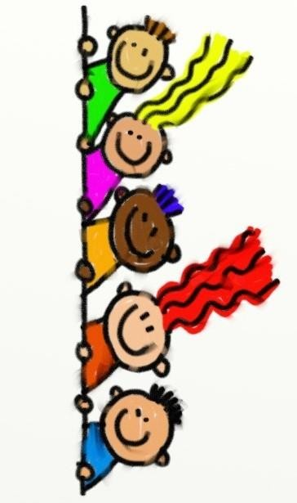Has someone hit, punched or smacked you or hurt you in anyway?

You must tell someone at the school so we can help you.

Examples of people you can tell are:

* + **Your Class Teacher**
  + **Mrs Hinton**
  + **Mr Padotan**
  + **Your Learning Support Assistant**
  + **Your Safeguarding Team**
  + **Your Lunchtime Staff**
  + **ANYONE who works in our school**

If in doubt, talk to someone. There are many staff at school for you to talk to and they will help support you.

**The four main areas of Child Protection concerns are:**

1. **Physical Abuse** – hitting, smacking, shaking, throwing, burning, biting etc
2. **Sexual Abuse** – be aware this doesn’t always mean actually touching a child. It could be someone making you watch things to do with sex or en- couraging you to act in an inappropriate way.
3. **Neglect** – this means things like not providing meals or warmth or cloth- ing. Or perhaps not taking you to the Doctors when you need to go. There may be lots of different reasons why a child is neglected and it is really important that we know so we can help.
4. **Emotional Abuse** – This means when someone upsets you or makes you feel bad. If someone in your family says horrible things to you and makes you feel sad and worthless.

Just are just a few examples for you and if you think you may have a problem that is similar to one of these then talk to someone to check.

### How does your school work to protect children?

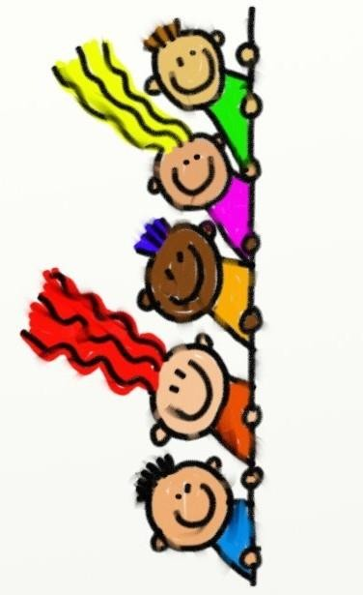There are lots of different ways, but one of the main ways is making sure the staff here at St Philip’s Catholic Primary School know how to keep you safe and also make sure you have someone to talk to if you need to.

The staff at school are here to support young people and their families if there is a Child Protection concern.

Safeguarding and Child Protection mean we look after children and keep them safe.

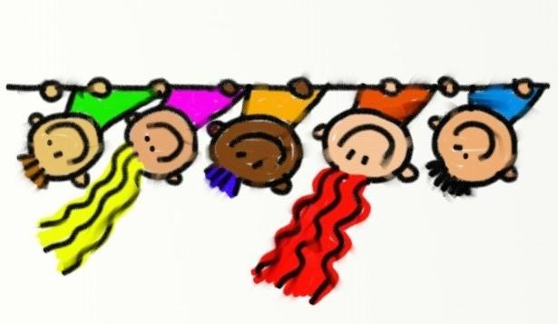

**Staying Safe TOP 10 TIPS**

* 1. Do not talk to strangers
  2. Do not accept presents from strangers
  3. Do not let strangers in to the school building
  4. Always tell someone you trust where you are going
  5. Only have people you know on your social media site or on gaming sites
  6. If you are worried about the way someone around you is behaving, talk to an adult you trust or ring Childline on

0800 1111.

You can also speak to [www.kooth.com](http://www.kooth.com/)

* 1. Never give out information about yourself online or share your passwords
  2. Never send pictures of yourself or your home or school to anyone
  3. Do not take pictures of anyone or share them without their permission
  4. Never get into a vehicle with someone you don’t know
  5. Be a good friend and look out for each other
  6. Ask for support if you need it and know there are always people who are there for you
  7. No one should ever make you feel uncomfortable and tell you to keep it a secret

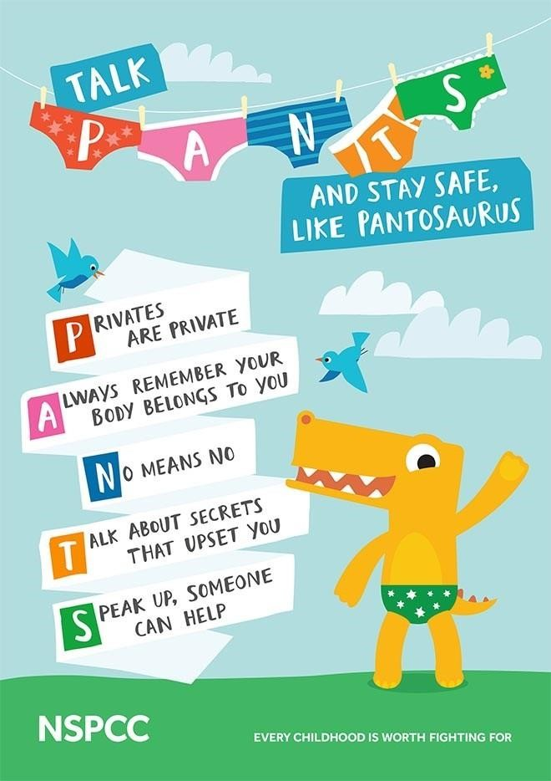



**What are the next steps?**

Sometimes a member of staff at your school will need to check things with the Safeguarding Team and then if they can deal with the issue themselves, they will.

There are times though when they may need to contact some other agencies for support. These may be Children’s Social Care (Social Workers) or Police.

There are lots of other agencies who support children and their families as well.

Your Safeguarding Team will talk to you and explain all of this and you can always go and ask them questions if you are unsure about anything.

Signature: C.Hinton (Principal) 1 September 2024

Signature: S.Godber (Chair of Governors) 1 September 2025